GENERATOR INTERCONNECTION APPLICATION
For All Projects with Aggregate Generator Output
Less Than or Equal to 550 Kw
Also Serves as Application for Distributed Generation Program

ELECTRIC UTILITY CONTACT INFORMATION |  |  |  | FOR OFFICE USE ONLY
Consumers Energy  Interconnection Coordinator  1945 West Parnall Road (Room P12-235)  Jackson, MI 49201  517-788-1432  Interconnection E-mail: customer.generation@cmsenergy.com |  |  |  | Application Number
 |  |  |  | Date and Time Application Received
CUSTOMER / ACCOUNT INFORMATION
Electric Utility Customer Information (As shown on utility bill)
Name or Entity on Electric Account |  | Customer Mailing Address (Street, City, State, and Zip Code)
Customer Phone Number  ( ) |  | Customer E-mail Address
Electric Service Account(s) # |  | Electric Service Meter Number(s)
Note: If multiple meters on site for interconnection, please list all account and meter numbers with a “;” between each.
Are you applying for the Distributed Generation Program? (Note: Level 3 Distributed Generation Program Only Available to Methane Digester Projects). Marking “no” means “interconnection only”  Yes No |  | What Level are you applying for?  1 (< 20kW certified Inverter-based project)  2 (> 20kW and < 150kW certified Inverter-based project)  3 (> 150kW and < 550kW certified Inverter-based project OR < 550 non-certified Inverter-based project)
Are you interested in selling Renewable Energy Credits? (Optional)  Yes No |  | Do you have another Electric Supplier that is not Consumers Energy?  Yes No If Yes, Name
Does this project involve renovation to an existing structure or new construction? Yes or No |  | Rate Type: residential, commercial, or industrial
Does the site have electric service? Yes or No
Notes: 1. Account/meter not required for new construction where a permanent meter has not been installed.
2. You must apply to both the Distribution Utility and your Alternate Energy Provider (if applicable) for Distributed Generation
3. If you are applying for Distributed Generation, you may also apply online at https://consumersenergy.powerclerk.com
INSTALLATION INFORMATION
Project Single Point of Contact: (Electric Utility Customer, Installer or Other)
Name | Company (If Applicable) |  |  |  | Phone Number  ( )
E-Mail Address |  |  |  |  | Requested In-Service Date (Optional)
Installer (Name of Firm or Self)

Installer Name (Last, First, MI) | Installer Phone # |  |  |  | Installer E-mail
EXISTING GENERATION ON SITE
Other than electrically isolated backup generation, are there any existing generators on site? (Are you modifying or adding capacity to an existing system?) Yes No |  |  | What program is the existing generation enrolled in?
System Type (Solar, Wind, Anaerobic Digester, Diesel, Other etc.) |  | Other System Type:
Existing Generator(s) Aggregate Nameplate Capacity
kW

GENERATION SYSTEM SITE INFORMATION
Physical Site Service Address (If Not Billing Address). Include City and Zip Code

Physical Site Township |  |  | Physical Site County
Annual Site Requirements Without Generation in kWh  kWh/year |  |  | Peak Annual Site Demand in kW (only for Industrial customers billed on Demand Rates)  kW
Attached Site Plan  Page # |  |  | Attached Electrical One-Line Drawing  Page #
Level 1 and 2 do not need to show any proof of insurance.
(Attach) Level 3 Applicant’s Proof of General Liability Insurance for a minimum of $1,000,000. Per MSPC rule – Applicant must maintain a minimum of $1,000,000 General Liability Insurance for Level 3 ONLY.
Level 1 and 2 proof of site control may be demonstrated by the site owner’s signature and contact information on the application.
Level 3 site control may be demonstrated by providing documents (must be attached):
- Ownership of, a leasehold interest in, or a right to develop a site for the purpose of constructing and operating a DER.
- An enforceable option to purchase or acquire a leasehold site
- A legally binding agreement transferring a present real property right to specified real property along with the right to construct and operate a DER on the specified real property for a period not less than 5 years.
GENERATION SYSTEM MANUFACTURER INFORMATION
System Type (Solar, Wind, Anaerobic Digester, Diesel, etc.) |  |  | Generator Type (Inverter, Induction, Synchronous)
Total Generator(s) Nameplate AC Rating  kW |  |  | Expected Annual Output in Kilowatt Hours  kWh/year
Generator A.C. Operating Voltage |  |  | Wiring Configuration (Single Phase, Two Phase, Three Phase)
Export Capacity (kW): |  |  | If power limited, list protective method (reverse power relay, min-import relay, UL PCS Certification, Load Offset):
If load offset, list the verifiable minimum load:

BATTERY STORAGE INFORMATION
Will a stored energy system be onsite (Battery)  Yes No |  |  | Is the battery AC or DC coupled:
Battery manufacturer: |  |  | Battery Model Name:
Battery Model Number: |  |  | Battery Power Rating (kWh):
Battery Chemistry Type: Lead Acid, Lithium Ion, Lithium Iron Phosphate or Other: |  |  | Other Chemistry Type:
Battery Max Output Rating (kW): |  |  | Storage Capacity (kWh):
# of Batteries onsite: |  |  | Include Battery Spec Sheet(s)
METER SOCKET DETAIL INFORMATION (Level 2 and 3 only)
Electrician’s Name: |  | Electrician’s phone number:
Electric phase: Single or Three: |  | How many wires (2 or 3) for the Single Phase configuration:
How many wires (3 or 4) for the Three Phase configuration: |  | What is the wire gauge leaving the panel going into the meter socket:
Single or Parallel conductor going in? |  | Wire size coming out of the meter socket (level 2 and 3 generator Meter info):
Is the service to the site Overhead (OH) or Underground (UG): |  | Single or Parallel conductor coming out?
Generator AC Operating Voltage (120/240, 240/480, 120/208 three phase or 480* (*with Consumers Energy approval only):
Meter socket pickup location is based on the nearest Consumers Energy Service Center to the project. Consideration may be taken if your requested pickup location is different than assignment.
METER SOCKET RETRIEVAL WILL NOT BE AVAILABLE UNTIL APPROVAL HAS BEEN GRANTED FOR CONSTRUCTION.
Meter Socket requested pick up location: |  | Meter socket requested pick up date:
Microinverter Policy
Once the project has been approved for construction, pictures of installed equipment must be submitted on forms. Microinverter picture submissions should include one of the following:
- Pictures of all uninstalled microinverters at the physical location including unique identifiers such as a serial number. Pictures that are not taken at the physical location will result in return for correction.
- A Manufacturer System Summary Report may be provided in lieu of pictures providing it has the following identifiers:
  - Physical site location of the installed equipment.
  - Unique serial or manufacturer number(s) of installed equipment.
  - Equipment numbers should not be the same as other installs.
  - Date report was generated.
Notes: 1. All applications require an attached Site Plan and Electrical One-Line Drawing
2. See Page 7 for reference sample Site Plan
3. See Page 9 for reference sample Inverter Generator Electrical One-Line Drawing
4. See Page 11 for reference sample Synchronous Generator Electrical One-Line Drawing
5. See Page 13 for reference sample Induction Generator Electrical One-Line Drawing
6. For Levels 2 and 3, the One-Line Drawing must be signed and sealed by a licensed
professional engineer, licensed in the State of Michigan or by an electrical contractor licensed by the State of Michigan with the electrical
contractor’s license number noted on the diagram.
INVERTER GENERATOR - BASED SYSTEMS
Manufacturer | Model (Name/Number) |  |  | Inverter Power Rating (kW)  kW
Number of Inverters | Total Generator(s) Nameplate AC Rating  kW |  |  | Total Generator(s) Nameplate DC Rating, where applicable  kW
Is this inverter(s) certified? | Is the Inverter tested to IEEE 1547.1?  Yes No
SYNCHRONOUS AND INDUCTION GENERATOR - BASED SYSTEMS
The following information on these system components shall appear on the Electrical One-Line Drawing:
- Breakers – Rating, location and normal operating status (open or closed)
- Buses – Operating voltage
- Capacitors – Size of bank in kVAR
- Circuit Switchers – Rating, location and normal operating status (open or closed)
- Current Transformers – Overall ratio and connected ratio
- Fuses – Normal operating status, rating (Amps) and type
- Generators – Capacity rating (kVA), location, type and method of grounding
- Grounding Resistors – Size (Ohms) and current (Amps)
- Isolating Transformers – Capacity rating (kVA), location, impedance, voltage ratings, primary and secondary connections, and method of grounding
- Potential Transformers – Ratio and connection
- Reactors – Ohms per phase
- Relays – Types, quantity, IEEE device numbers, and operator lines indicating the device initiated by the relays
- Switches – Location and normal operating status (open or closed), type, and rating
- Tagging Point – Location and identification

CUSTOMER AND PROJECT DEVELOPER/CONTRACTOR SIGNATURES AND FEES
Non-Export Application Only
$100 + $1/kWac (certified) $100 +$2 / kWac (non-certified) OR
Combined Interconnection Application and Distributed Generation
$50 (Levels 1 - 3) OR
Interconnection Application Only (No Distributed Generation)
$100 + $1/kWac (certified) $100 +$2 / kWac (non-certified)
Check # Money Order #

Please send a check for the fee payable to Consumers Energy along with the signed and completed application to:
Consumers Energy
Interconnection Coordinator
1945 West Parnall Road (Room 12-235)
Jackson, MI 49201

To the best of my knowledge, all the information provided in this application form is complete and correct.
This application is being submitted by Customer Developer/Installer

Signature: Date

Project Developer/Installer Signature (if applicable): Date

Note: Refer to the applicable “Consumers Energy Company Generator Interconnection Requirements” for a detailed explanation of the Interconnection Process, Fees, Timelines, and Technical Requirements.

SYNCHRONOUS GENERATORS
GENERATOR INFORMATION
Generator Nameplate Voltage |  | Generator Nameplate Watts or Volt-Amperes
Generator Nameplate Power Factor (pf) |  | RPM
Manufacturer | Model Name |  | Model Number
TECHNICAL INFORMATION
Minimum and Maximum Acceptable Terminal Voltage |  | Direct Axis Reactance (saturated) in ohms
Direct Axis Reactance (unsaturated) in ohms |  | Quadrature Axis Reactance (unsaturated) in ohms
Direct Axis Transient Reactance (saturated) in ohms |  | Direct Axis Transient Reactance (unsaturated) in ohms
Quadrature Axis Transient Reactance (unsaturated) in ohms |  | Direct Axis Sub-Transient Reactance (saturated) in ohms
Direct Axis Sub-Transient Reactance (unsaturated) in ohms |  | Leakage Reactance
Stator Resistance in ohms |  | Negative Sequence Reactance in ohms
Zero Sequence Reactance in ohms |  | Neutral Grounding Resistor in ohms (If Applicable)
Direct Axis Transient Open Circuit Time Constant |  | Quadrature Axis Transient Open Circuit Time Constant
Direct Axis Sub-Transient Open Circuit Time Constant |  | Quadrature Axis Sub-Transient Open Circuit Time Constant
Open Circuit Saturation Curve

Reactive Capability Curve Showing Overexcited and Underexcited Limits (Reactive Information if Non-Synchronous)

Excitation System Block Diagram with Values for Gains and Time Constants (Laplace Transforms)

Short Circuit Current Contribution From Generator at the Point of Common Coupling

Rotating Inertia of Overall Combination Generator, Prime Mover, Couplers and Gear Drives

Station Power Load When Generator is Off-Line (Watts, pf) |  | Station Power Load During Start-Up (Watts, pf)
Station Power Load During Operation (Watts, pf)

INDUCTION GENERATORS
GENERATOR INFORMATION
Generator Nameplate Voltage |  | Generator Nameplate Watts or Volt-Amperes
Generator Nameplate Power Factor (pf) |  | RPM
Manufacturer | Model Name |  | Model Number
TECHNICAL INFORMATION
Synchronous Rotational Speed |  | Rotation Speed at Rated Power
Slip at Rated Power |  | Minimum and Maximum Acceptable Terminal Voltage
Motoring Power (kW) |  | Neutral Grounding Resistor in ohms (If Applicable)
I2 2t or K (Heating Time Constant) |  | Rotor Resistance in ohms
Stator Resistance in ohms |  | Stator Reactance in ohms
Rotor Reactance in ohms |  | Magnetizing Reactance
Short Circuit Reactance |  | Exciting Current
Temperature Rise |  | Frame Size
Design Letter |  | Reactive Power Required in Vars (No Load)
Reactive Power Required in Vars (Full Load)

Short Circuit Current Contribution from Generator at the Point of Common Coupling

Rotating Inertia, H in Per Unit on kVA Base, of Overall Combination Generator, Prime Mover, Couplers and Gear Drives

Station Power Load When Generator is Off-Line (Watts, pf) |  | Station Power Load During Start-Up (Watts, pf)
Station Power Load During Operation (Watts, pf)

SAMPLE SITE PLAN – PROVIDED FOR REFERENCE ONLY
Can be a separate document

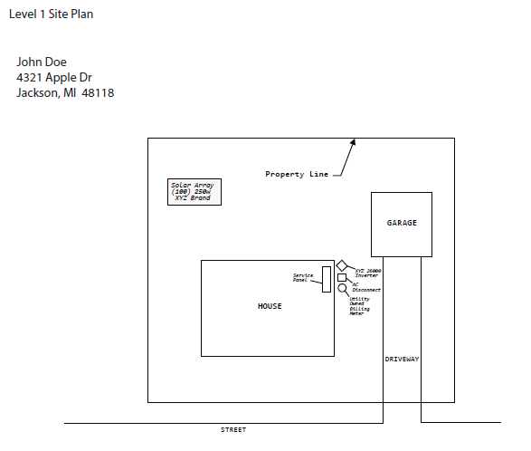

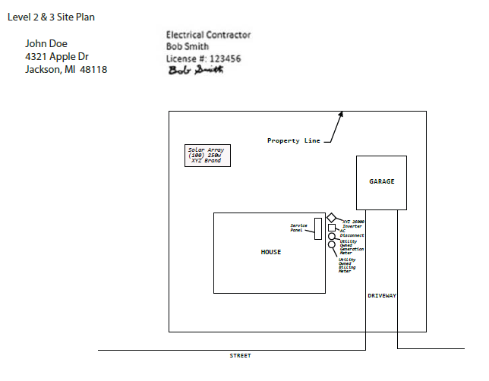

Weblink to State of Michigan / Plats:

http://www.cis.state.mi.us/platmaps/sr_subs.asp

Note: Legible hand drawn site plans are acceptable. Level 3 should be not hand-drawn.

SAMPLE ELECTRICAL ONE-LINE DRAWING – PROVIDED FOR REFERENCE ONLY
Can be separate document

INVERTER GENERATOR
PE Stamp required for levels 2 & 3
Level 2 can have a Licensed Contractor stamp instead of PE Stamp

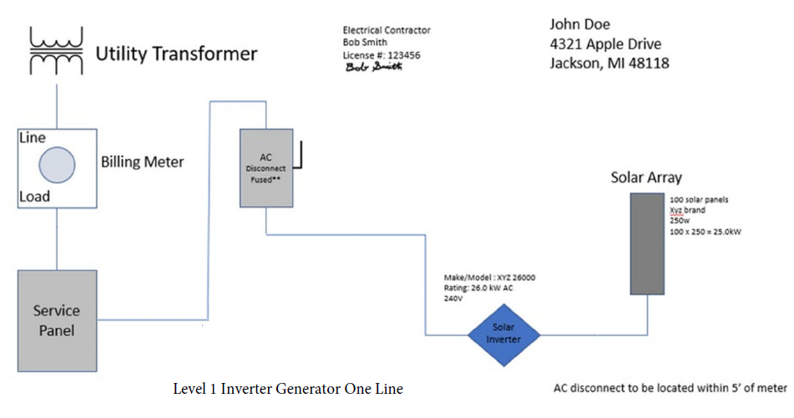

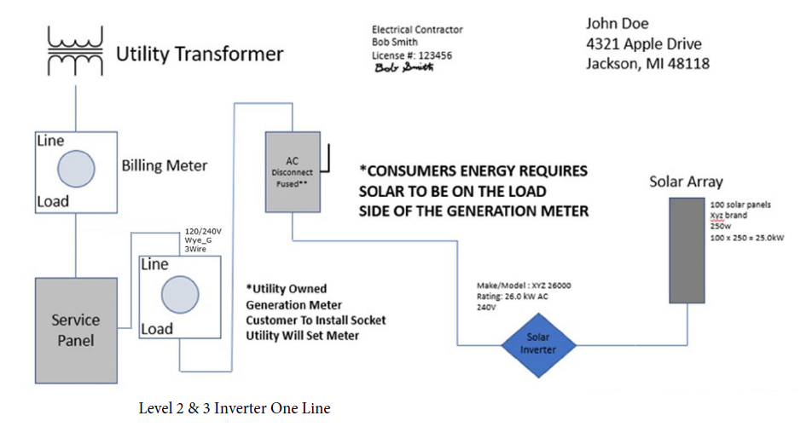

Note: Legible Hand Drawn One-Line is Acceptable
SAMPLE ELECTRICAL ONE-LINE DRAWING – PROVIDED FOR REFERENCE ONLY
TYPICAL ISOLATION AND FAULT PROTECTION FOR SYNCHRONOUS GENERATOR

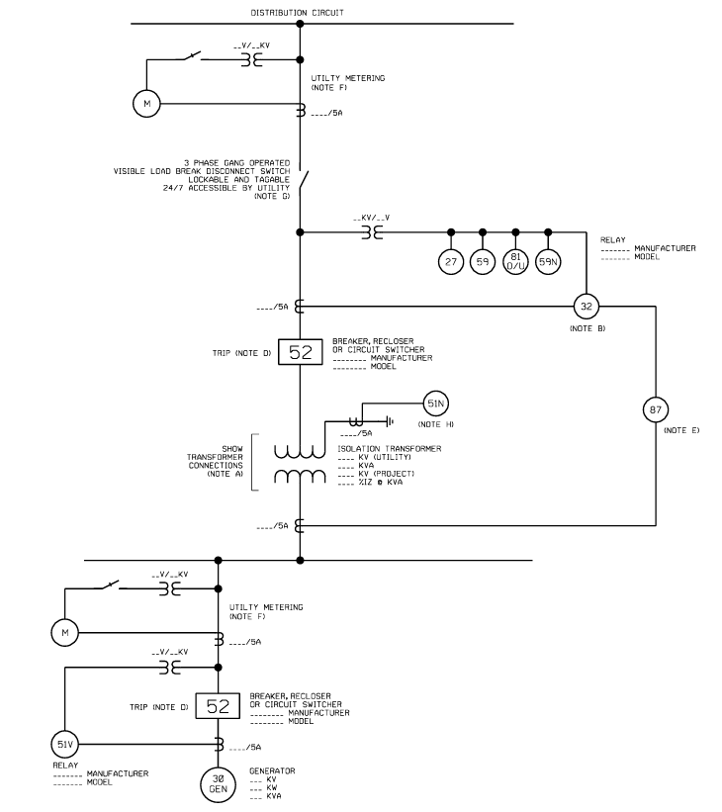

LEGEND
27 Undervoltage
32 Reverse Power (Not Required for Flow-Back)
51N Neutral overcurrent (required for grounded secondary)
59 Overvoltage
59N Zero sequence overvoltage (assuming ungrounded secondary on power transformer)
81o/u Over/Underfrequency

NOTES
A) See technical requirements for permissible transformer connections. Transformer connections proposed shall be shown on the one-line diagram by the Applicant. Transformer connections and primary grounding to be approved by Utility.

B) The 27, 59, 59N, and 81O/U relays shall be connected to VTs located at the point of common coupling, unless otherwise approved by Consumers Energy. VTs connected to the Project side of transformers without zero sequence continuity (e.g. ungrounded wye or delta winding connections) on a grounded distribution system is not allowed.

C) Any additional equipment necessary to protect the Project is the sole responsibility of the Applicant to determine, design, and apply.

D) Tripping of an approved interrupting device between the point of common coupling and distributed energy resource is acceptable, depending on if the Applicant wants to serve its own isolated load after loss of Utility service.

E) Transformers 15 MVA (self-cooled rating) or larger shall be equipped with differential (87) relaying.

F) Utility metering equipment will be supplied by the utility.

G) The isolation device is to be located on the utility side of the metering CTs and VTs when connected to the high voltage distribution system.

H) The 51N relay is required for isolation transformers with a Delta (Project) and Grounded Wye (Utility) winding connections. Refer to Note A for permissible transformer connections.

SAMPLE ELECTRICAL ONE-LINE DRAWING – PROVIDED FOR REFERENCE ONLY
TYPICAL ISOLATION AND FAULT PROTECTION FOR INDUCTION GENERATOR

PE Stamp required for levels 2 & 3
Level 2 can have a Licensed Contractor stamp instead of PE Stamp

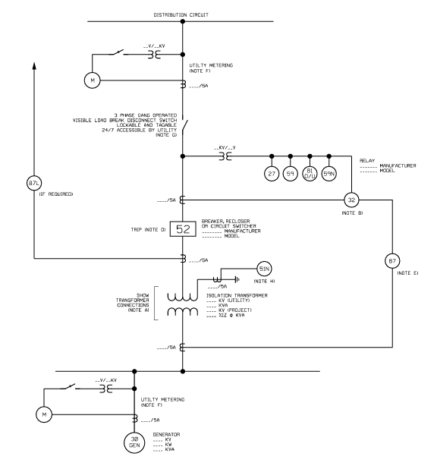

LEGEND
27 Undervoltage
32 Reverse Power (Not Required for Flow-Back)
51N Neutral overcurrent (required for grounded secondary)
59 Overvoltage
59N Zero sequence overvoltage (assuming ungrounded secondary on power transformer)
81o/u Over/Underfrequency

NOTES
A) See technical requirements for permissible connection configurations and protection. Transformer connections proposed shall be shown on the one-line drawing by the Applicant. Transformer connection and secondary grounding to be approved by Utility.

B) The 27, 59, 59N, and 81O/U relays shall be connected to VTs located at the point of common coupling, unless otherwise approved by Consumers Energy. VTs connected to the Project side of transformers without zero sequence continuity (e.g. ungrounded wye or delta winding connections) on a grounded distribution system is not allowed.

C) Any additional equipment necessary to protect the Project is the sole responsibility of the Applicant to determine, design, and apply.

D) Tripping of an approved interrupting device between the point of common coupling and distributed energy resource is acceptable, depending on if the Applicant wants to serve its own isolated load after loss of Utility service.

E) Transformers 15 MVA (self-cooled rating) or larger shall be equipped with differential (87) relaying.

F) Utility metering equipment will be supplied by the utility.

G) The isolation device is to be located on the utility side of the metering CTs and VTs when connected to the high voltage distribution system.

H) The 51N relay is required for isolation transformers with a Delta (Project) and Grounded Wye (Utility) winding connections. Refer to Note A for permissible transformer connections.

